Android Devlopment

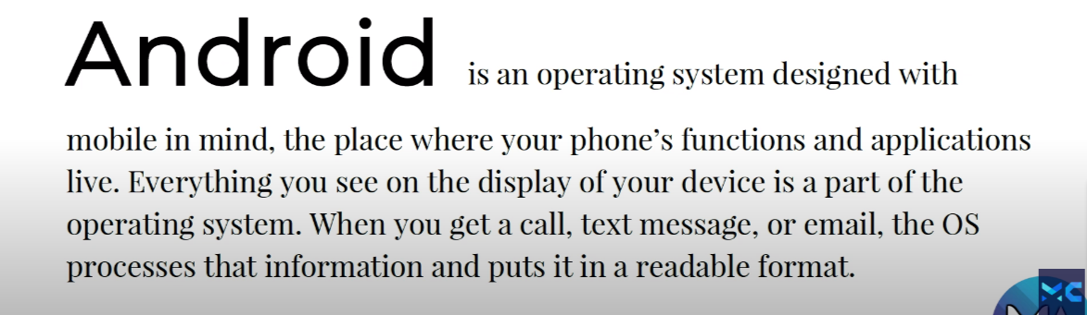

i)Temprory attributes :

Eg : android:textAppearance:”?android:textAppreanceLarge”

ii)Shortcut to text decoration in android studio

i)ctrl+a

ii)ctrl+alt+L

1.Layout

A.)LinearLayout : it has two orintation -> i)horizantal ii)vertical

<https://www.geeksforgeeks.org/linearlayout-and-its-important-attributes-with-examples-in-android/>

🡪type of view

i)TextView

ii)ButtonView

iii)ImageView

B)RelativeLayout : it is relative to the parent or relative to other children

<https://www.geeksforgeeks.org/relative-layout-in-android/>

🡪Relative to parent attributes

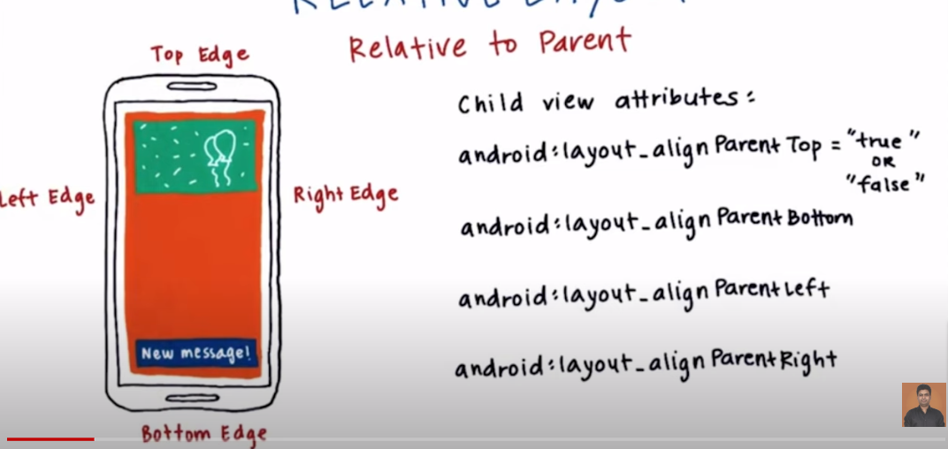

🡪Relative to child

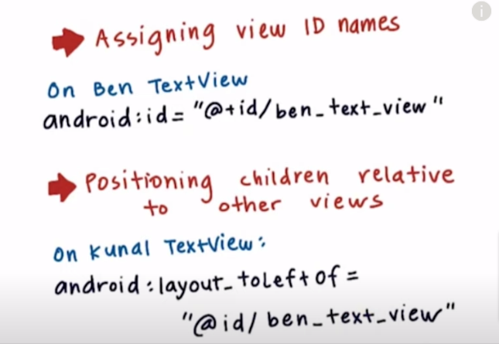

Attributes:

i)toLeftOf ii)toRightOf iii)toEndOf iv)toStartOf v)above vi)below

🡺Padding and margin